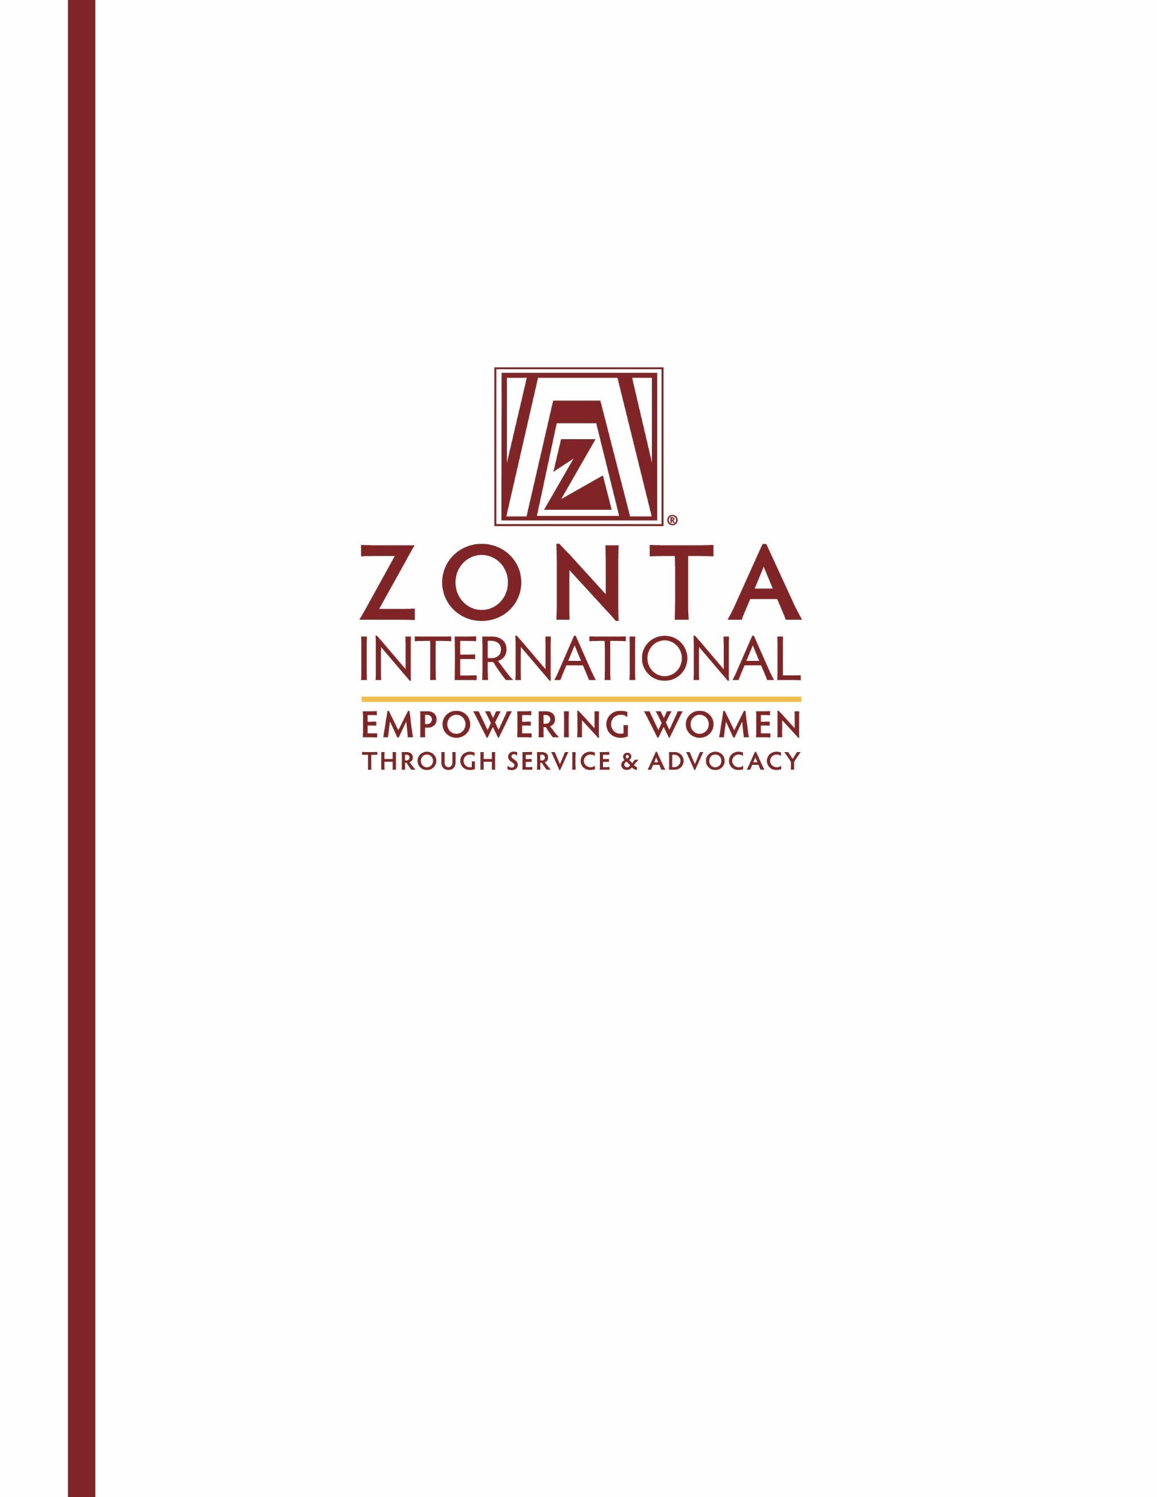

Young Women in Public Affairs Award

2017 Application

Heading
Subheading

Young Women in Public Affairs Award
A Zonta International Program, Funded by the Zonta International Foundation

General Information
The goal of the Zonta International Young Women in Public Affairs (YWPA) Award Program is to encourage more young women to participate in public affairs by recognizing a commitment to the volunteer sector, evidence of volunteer leadership achievements and a dedication to empowering women worldwide through service and advocacy.

In order for more women to be represented in key decision making positions worldwide, we must encourage young women to pursue careers or seek leadership positions in public policy making, government and volunteer organizations and further their education with these aims in view.

Public affairs refer to all aspects of community life where decisions have to be made about issues which relate to and affect those communities in which people work and live.

The Awards
Zonta clubs usually provide awards for club recipients. District/region recipients receive US$1,000. Ten international recipients are selected from the district/region recipients to receive additional awards of US$4,000 each. District/region and international awards are funded by the Zonta International Foundation.

Who is Eligible?
Women, ages 16-19 on 1st April each year, living in a Zonta district/region, or a citizen of a Zonta country, who demonstrate evidence of the following, are eligible to apply. Note that applicants from geographic areas within a Zonta district/region where no clubs are located will be considered and also eligible to apply for the district/region Award. Z and Golden Z club members are also eligible to apply. Classified members and employees of Zonta International and Zonta International Foundation, and their family members, are not eligible to apply for the Awards.

- Active commitment to volunteerism.
- Experience in local government, student government, or workplace leadership (paid or unpaid).
- Volunteer leadership achievements.
- Knowledge of Zonta International and its programs.
- Support for Zonta International’s mission of empowering women worldwide through service and advocacy.

Application Requirements
- Completion of the official application (may be downloaded from the Zonta International website, www.zonta.org).
- Verification of current enrollment by school/institute official (if applicable), or
- Letter from employer stating employment (if applicable).
- Two confidential recommendations from adults, not related to the applicant, such as teachers, school officials/employee supervisors or community leaders.

Supporting documentation not requested will not be considered. All applications and supporting information become the property of Zonta International. Zonta International has final authority over any aspect of the Awards.

Application process
The application process must start with a Zonta club. All application materials must be received at a Zonta club by the printed deadline. If you downloaded the application, you must contact a Zonta club for deadline information. Please locate the Zonta club nearest you using the Club Locator at www.zonta.org, or e-mail your name and contact information to the International Young Women in Public Affairs Award Committee Chairman at ywpachairman@zonta.org.

Zonta clubs select one application to send to the Zonta governor/region representative. A district/region evaluating committee reviews the applications and selects one applicant per district/region to submit to Zonta International Headquarters. The Zonta International YWPA Committee recommends 10 international recipients from the district/region applications to the Zonta International Board. After approval by the Zonta International Board, the Zonta International Foundation provides awards and certificates to the district/region and international recipients.

Timetable
Application is posted on the Zonta International website (www.zonta.org) ........................................by 1 August
Applications received by Zonta clubs...……………..……………...…..…….…............. (Contact club for deadline)
Club recipients selected and applications received by governor/region representative........…................by 1 April
District/region recipients selected and applications received by Zonta International Headquarters..........by 1 May

Announcement of district/region, and international recipients……………………...………….…….......……1 July

Application for
Young Women in Public Affairs Award

Send applications and direct questions to:
Zonta Club of: | Landshut
c/o: | Elaine Bräuning
Address: | Laimgrubenweg 4
City/State: | 84028 Landshut
Province/Country:
Telephone: | +49 173 343 7060
Email Address: | pastpresident@zonta-landshut.de

Application Deadline: 24.02.2017

Name:
 | Last (Family) | First (Given) | Middle

Present Mailing Address:

City: |  | State: |  | Postal Code: |  | Country:

Telephone: |  | E-mail Address:

Birth Date: |  | Birthplace: |  | Country of Citizenship:
(date/month/year) (city/country)

Name and Address of School/Institute currently attending (if applicable):

Name and Address of Employer (if applicable):

Current year of study (if applicable):

PERSONAL GOALS
Please describe in short your anticipated course of study and current career interests, including whether and how you plan to be active in volunteer or community organizations. (150 words) Please provide the word count at the end of your answer.

DECLARATION BY APPLICANT
I certify that all of the information contained in my application form is accurate to the best of my knowledge and that I did not receive assistance in completing the essay portions of this application. I confirm that I am not a family member of a classified member and/or employee of Zonta International. I understand that, at the option of the Zonta club sponsoring the competition, I may be interviewed as a candidate for the Young Women in Public Affairs Award. I consent to the electronic or hard copy publication by Zonta International of material in my application.

Date |  | Signature

Please answer all questions below, noting the word limit for each. Preference will be given to those applicants who observe the word restrictions. In evaluating applications all questions are rated in equal value.
Question

1. Activities related to your school/workplace. Please include (a) your leadership experience, and (b) what you find most rewarding or valuable about your participation in these activities (no more than 200 words). Please provide the word count at the end of your answer.

2. Activities not related to your school/workplace. Describe the activities in which you participate as a volunteer that benefit other causes and any leadership roles you have had in those activities.
Please include with these activities a description of any experience in local government, international, or other projects
(no more than 200 words). Please provide the word count at the end of your answer.

3. International Awareness
Describe the activities you participate in which increase your experience, knowledge and understanding of other countries and their different customs (no more than 150 words). Please provide the word count at the end of your answer.

4. Status of Women in your Country and Worldwide
Describe your experience in empowering women worldwide through service and advocacy. Are there any issues which hinder women’s empowerment in your country and worldwide? Describe your ideas as to how they should be resolved (no more than 300 words). Please provide the word count at the end of your answer.

Checklist to be completed by applicant:
Verification of current enrollment by school/institute official (if applicable), or
Letter from employer stating employment (if applicable)
Completed application materials, typed in English
Two confidential recommendation letters with signatures
Applicant’s signature (required)

Recommendation for
Young Women in Public Affairs Award

Please return this form by: |  | 24.02.2017
To Zonta club of: | Landshut
c/o | Elaine Bräuning
Address: | Laimgrubenweg 4
Postal code/City/State/Country: | 84028 Landshut
Fax:
Email: | pastpresident@zonta-landshut.de

Applicant:
 | Last (Family) Name | First | Middle

Recommendation from:
 | Name (please print) | Position/Title

Recommendation for Applicant for Zonta International Young Women in Public Affairs Award
The applicant above has applied for a Zonta International Young Women in Public Affairs Award. Please discuss the applicant’s accomplishments, motivation, potential for public service and awareness of women’s and community issues. Note that you may instead write your recommendation letter on letterhead of your choice, sign and submit with this form. This recommendation form must be signed and submitted directly to the address above.

Date |  | Signature

Recommendation for
Young Women in Public Affairs Award

Please return this form by: | 24.02.2017
To Zonta club of: | Landshut
c/o | Elaine Bräuning
Address: | Laimgrubenweg 4
Postal code/City/State/Country: | 84028 Landshut
Fax:
Email: | pastpresident@zonta-landshut.de

Applicant:
 | Last (Family) Name | First | Middle

Recommendation from:
 | Name (please print) | Position/Title

Recommendation for Applicant for Zonta International Young Women in Public Affairs Award
The applicant above has applied for a Zonta International Young Women in Public Affairs Award. Please discuss the applicant’s accomplishments, motivation, potential for public service and awareness of women’s and community issues. Note that you may instead write your recommendation letter on letterhead of your choice, sign and submit with this form. This recommendation form must be signed and submitted directly to the address above.

Date |  | Signature

Verification of Current Enrollment
Young Women in Public Affairs Award

Please return this form by: | 24.02.2017
To Zonta club of: | Landshut
c/o | Elaine Bräuning
Address: | Laimgrubenweg 4
Postal code/City/State/Country: | 84028 Landshut
Fax:
Email: | pastpresident@zonta-landshut.de

School/Institute:

I certify that |  | is currently enrolled in
 | (name)

 | at
(grade level) |  | (name of school/institute currently attending)

(address of school/institute currently attending)

Date |  | Signature of School/Institute Official

(Official School/Institute Stamp)

